1. Open the image by using ImageJ with Olympus Plugin

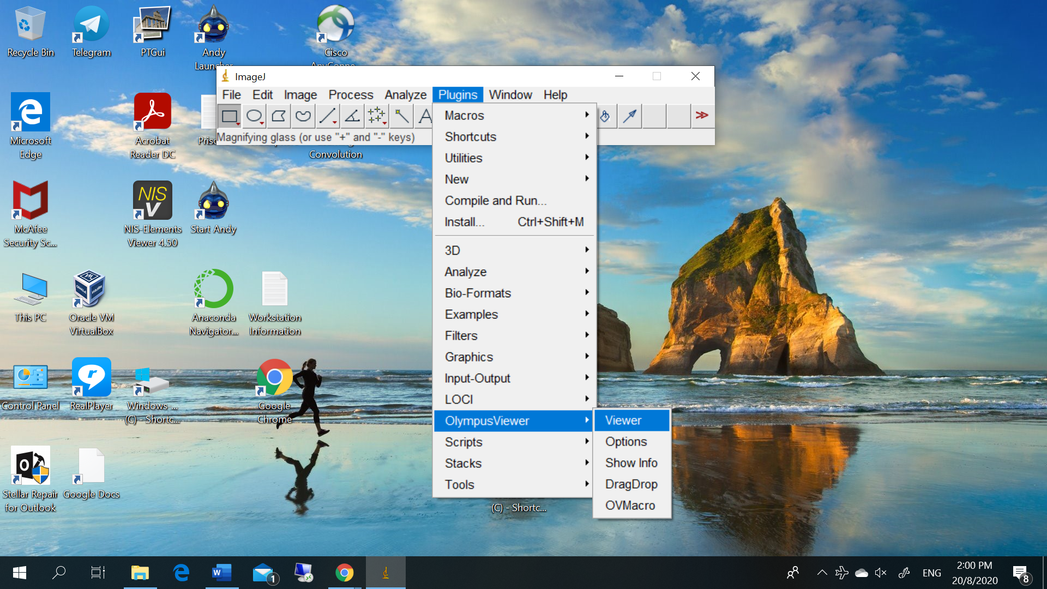

1. Choose the suitable image for viewing

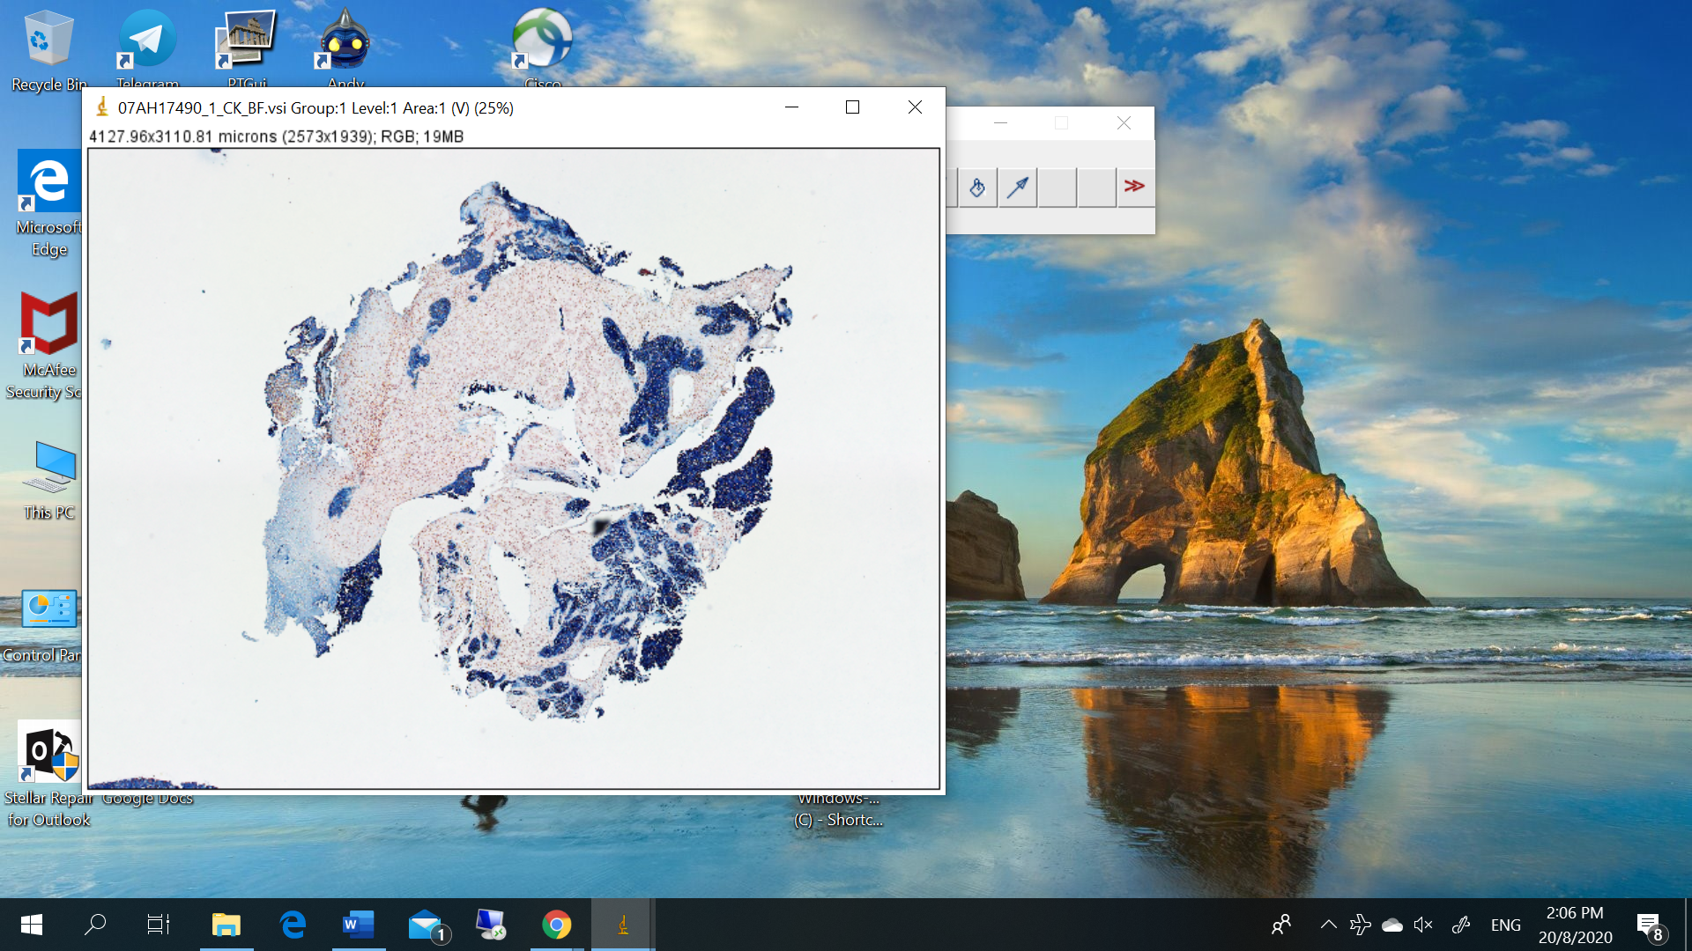

1. When I open the same image on Microsoft Paint, find out the there is a very great difference in Color, brightness and contrast !

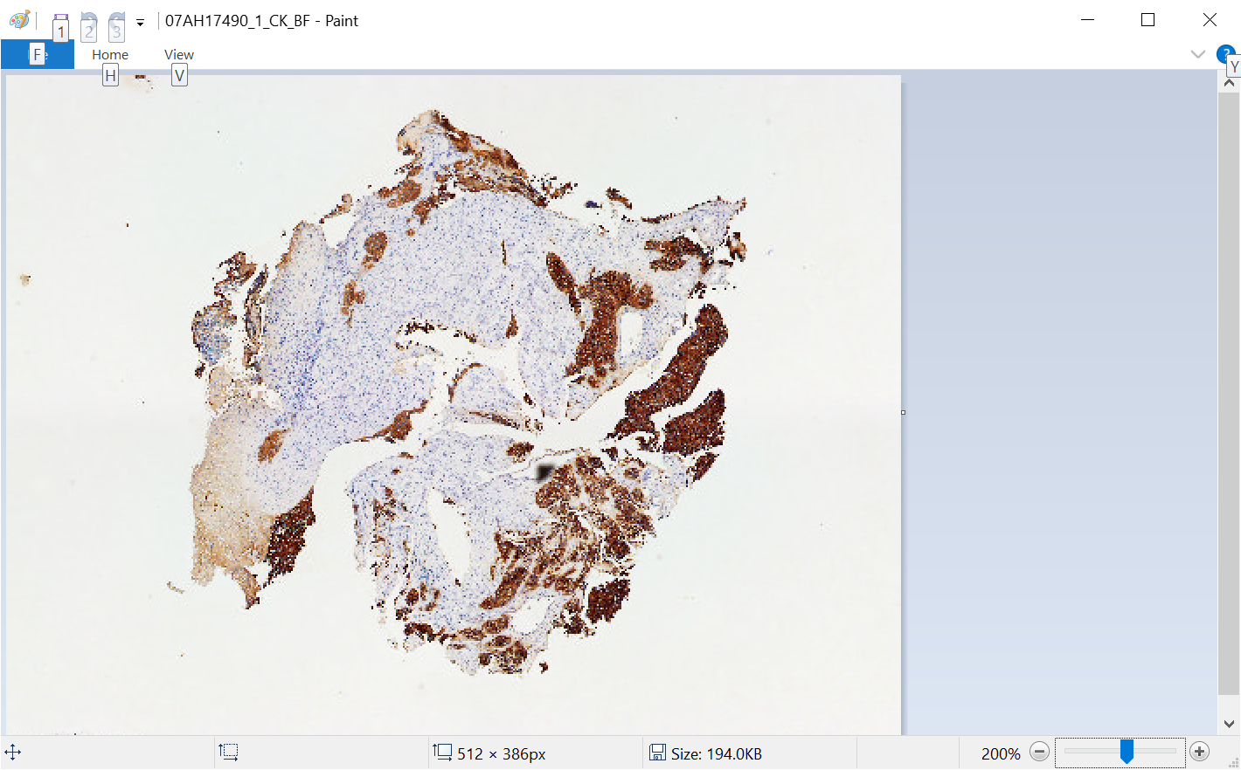

Same case occurs on Fluororescent image which got different brightness and contrast !

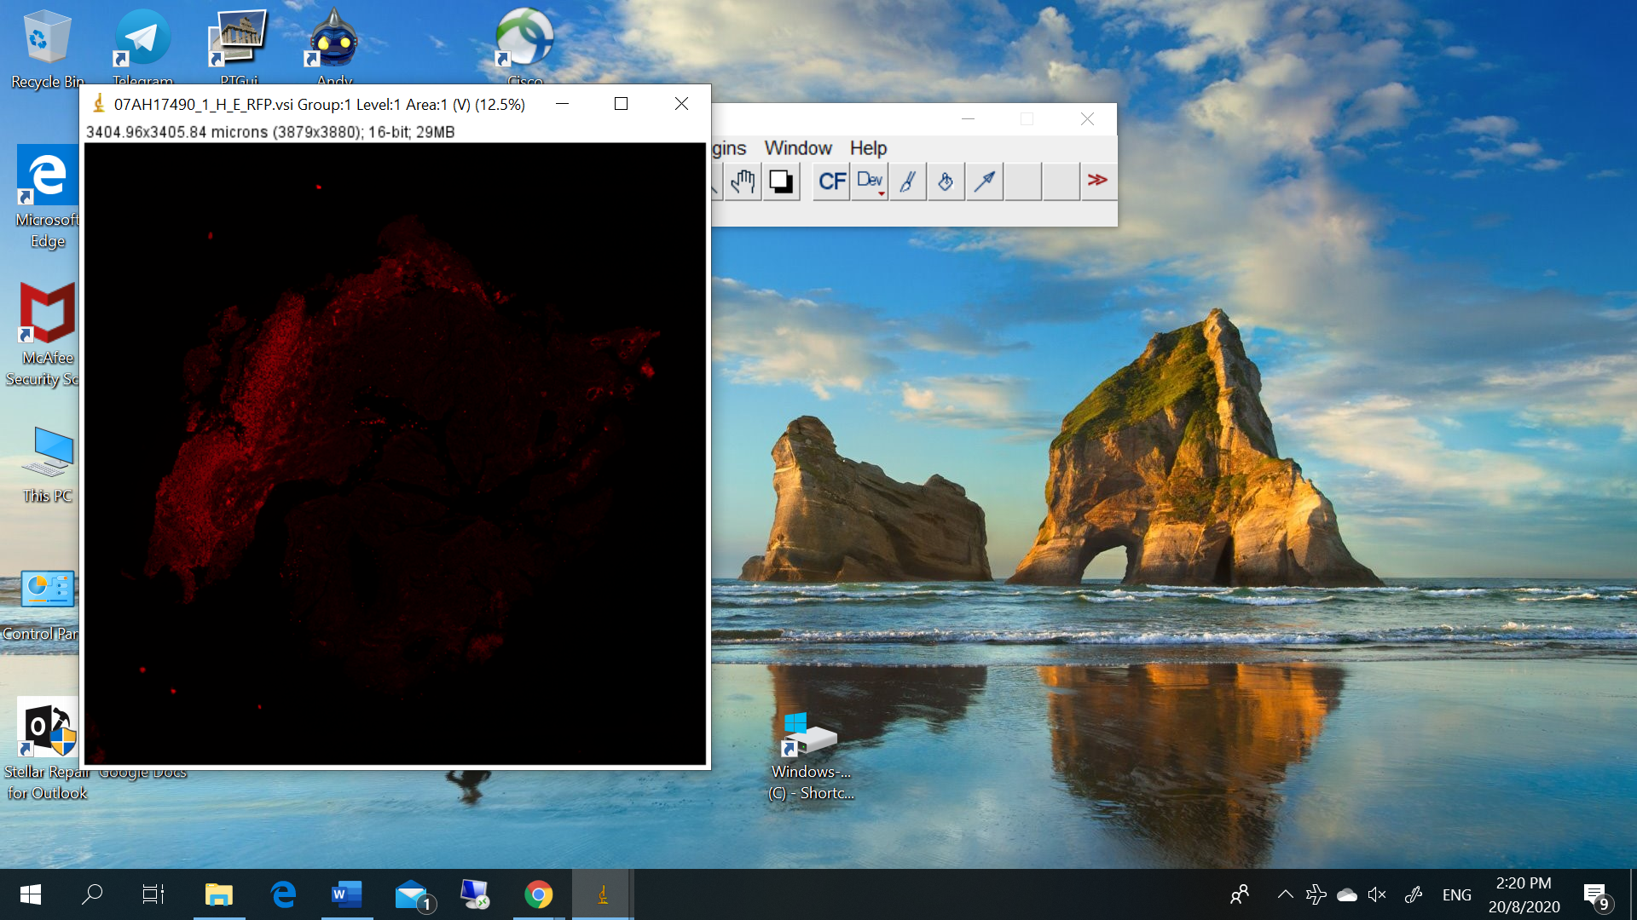

While the vsi opened in Microsoft Paint.

